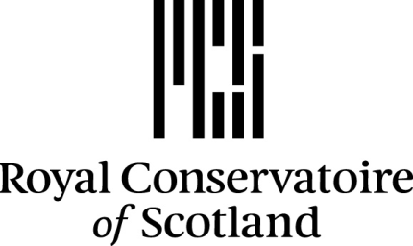

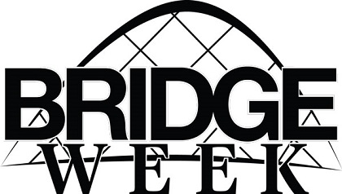

Project Proposal Form
The completed form must be submitted to
bridgeweek@rcs.ac.uk
before 5pm on Friday 20th March 2020

Name of Project

Which Venue are you pitching for (TICK ONE ONLY)
Chandler Studio Theatre
Stevenson Hall
New Athenaeum Theatre
Ledger Recital Room

OTHER (D2, R6, Rehearsal Room etc.)
Please Specify_______________________________________________

Name and RCS email of Main Contact / Project / Production Manager
(This person will be the sole contact with the Bridge Week Team and be responsible for allocated budget )

Brief Description of Project

Please provide a production schedule
(Include get-in / set-up times, rehearsal periods and proposed performance times. Also include get-out / tidy up and returns)

Please detail all estimated costs
Please provide a full list of all involved in the project, their RCS email and their roles
*NOTE – If you are using one of RCS licenced venues you must provide a full list of your technical team who must all be trained in using the technical equipment.
Please list ALL Royal Conservatoire resources that you propose to use for your project?
(Lighting equipment, Sound Equipment, Cameras, Props, Wardrobe Stock, Staging, Rehearsal Rooms, Dressing Rooms, Tools etc.)

Please list the activities that you will be providing Risk Assessments for
Please provide any other information that you think may be useful to support your proposal

