Process Drama
[CIRCLE]
Aby Watson

Rafael Tsantes
Nell O’Hara (Solo Week)
6/1/2020

Learning questions: What are the pros and cons of having a hierarchical system?

By the end of this workshop participants should have:
- Critically engaged with the ideas of hierarchy
- Actively reflected on how/why the system of Circle wasn’t successful
- Created a plan for a new system in a virtual world
Materials:
- Laptop/Desktop/Smartphone/Tablet accessibility
- Internet Connection
- Drawing materials e.g. markers, pens etc.
- A4 blank papers
- Pieces of clothing as props
- A recording device e.g. digital camera, smartphone etc.
Outline plan
- Video Message (in-character: Felicity Bell)
- The Fall of CIRCLE Cancellation Email
- Consider This…(Video out of character Raf)
- Task – Create/film New Manifesto
Detailed Plan
Each task is given in an individual “.pdf” page, making it clearer and easier for the participant to be engaged.
- Lure Video - (In-character Felicity Bell)
One of the facilitators is in-role within the world of Circle and delivers a message to the participants explaining that Circle, due to the strikes last week, has had to shut down and this will be her last video message.
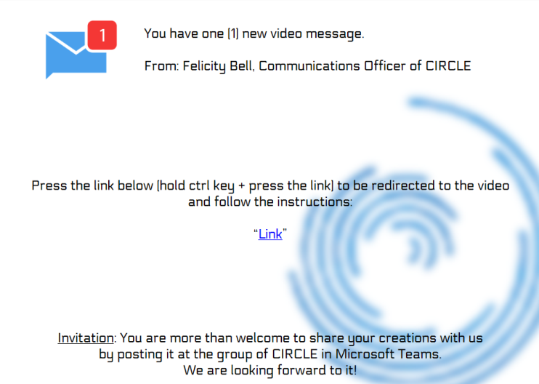
(video script)
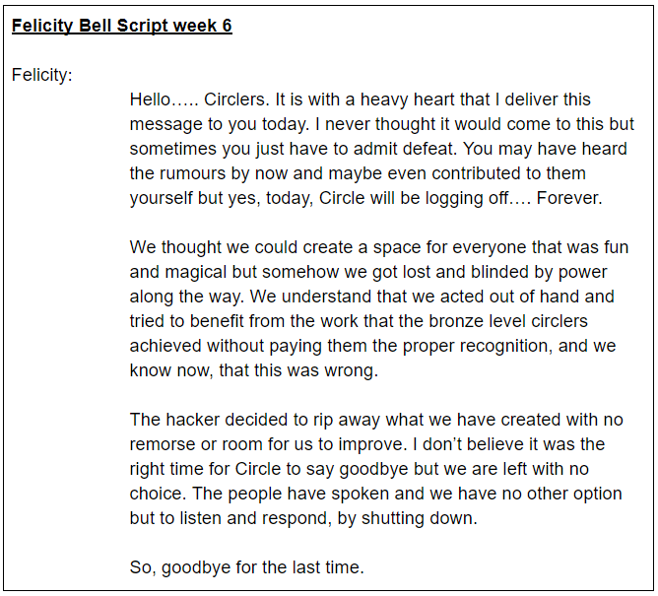
Link: “Link”
- Building Belief
They will be sent a notification which shows them that their membership with Circle has been cancelled and that they can’t log back into their account. It will be set up in the style of a cancellation email.
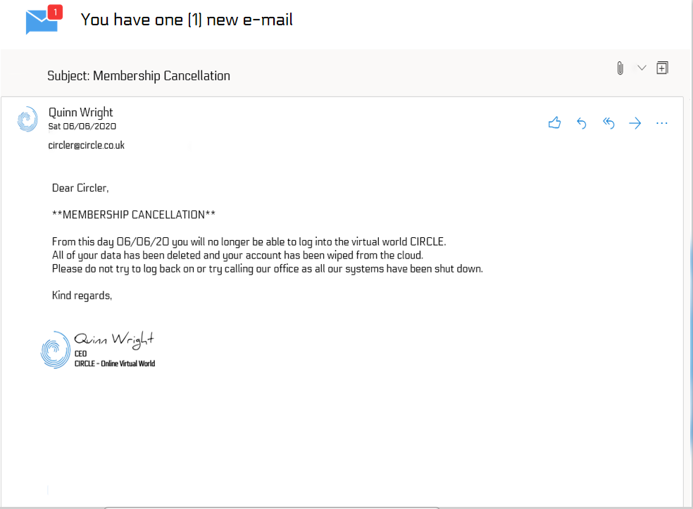

- Reflection - (out of character video from the other facilitator)
A video of both of the facilitators is then sent out to the participants which offers them some reflective moments on what has just happened. It allows them to take time to process that Circle has been shut down and then asks them important questions about their own experience such as ‘Are you happy with this outcome?’.
At the end of this video they will be set a task to write a manifesto for their very own personal virtual world, taking all of the things that they have learnt from Circle
(Video Script)
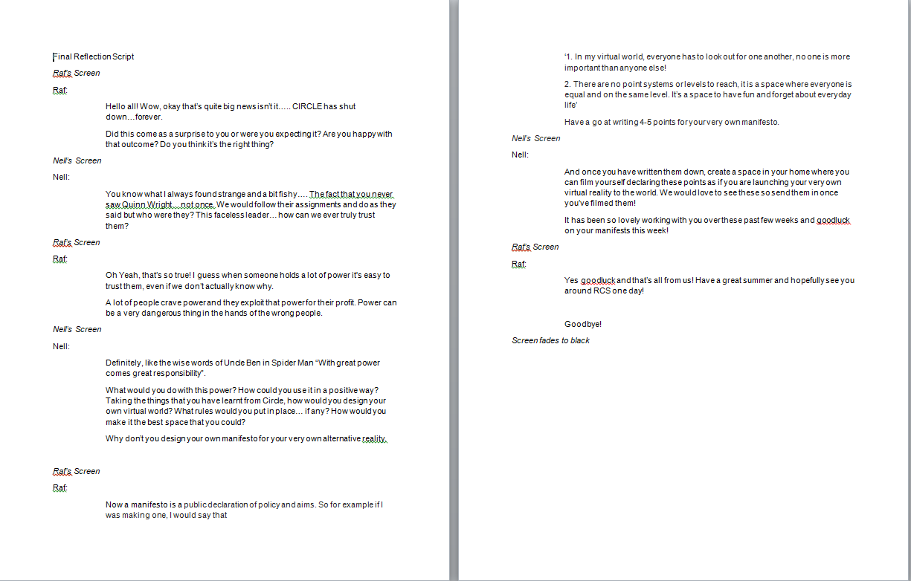
Link: “Link”

- Into Action
The participants will then begin to make their manifesto writing four to five points that they believe to be important in making a successful system. This will allow them to actively reflect on the things they have learnt from Circle and apply that into their work.
They will then dress up as if they are launching their new virtual reality to the world and film themselves presenting their manifesto.
Workshop ends

