Process Drama
[CIRCLE]
Aby Watson

Rafael Tsantes
Nell O’Hara
5/11/2020

Learning questions: Is it capitalism OR fairness the true problem of the system?

Themes that arise from the workshop are capitalism and fairness.

By the end of this workshop participants should have:
- Engaged with the idea of capitalism and fairness.
Materials:
- Laptop/Desktop/Smartphone/Tablet accessibility
- Internet Connection
- Drawing materials e.g. markers, pens etc.
- A4 blank papers
- Pieces of clothing as props
- A recording device e.g. digital camera, smartphone etc.
Outline plan
- Video Message (in-character)
- Next Move
- Message from Founder
- Consider This…
- Reflection Paper
Detailed Plan
Each task is given in an individual “.pdf” page, making it clearer and easier for the participant to be engaged.
- Lure: Video Message (in-character)
One of the facilitators assumes a character within the world of CIRCLE. They are the “Communications Officer” of CIRCLE and they introduce this week’s task. The video message is hacked by the Hacker No 251 (another facilitator in-role) who asks from the participants to address the unfairness of the point system of CIRCLE.
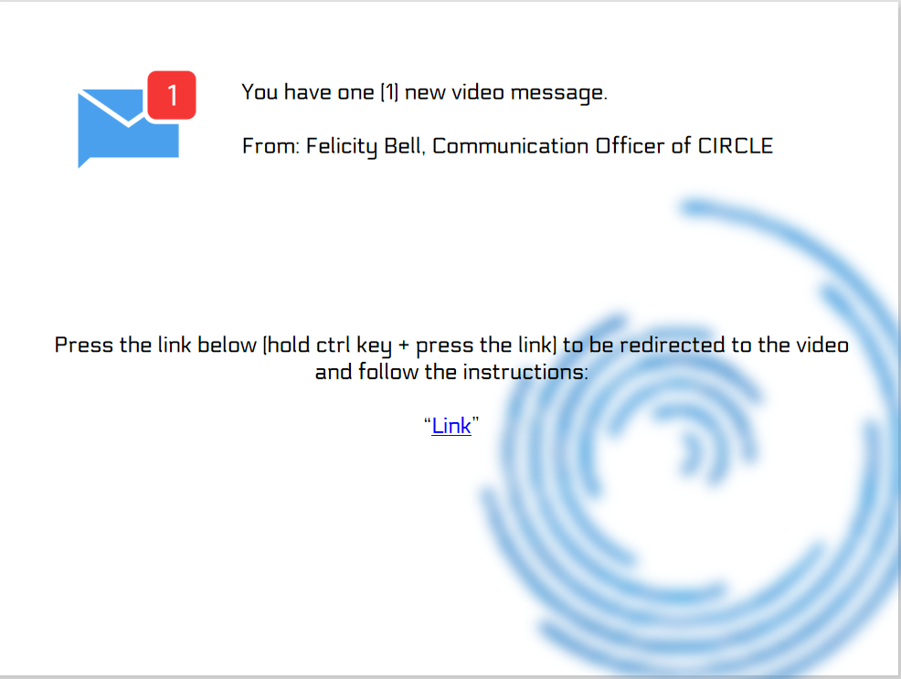

(video script)
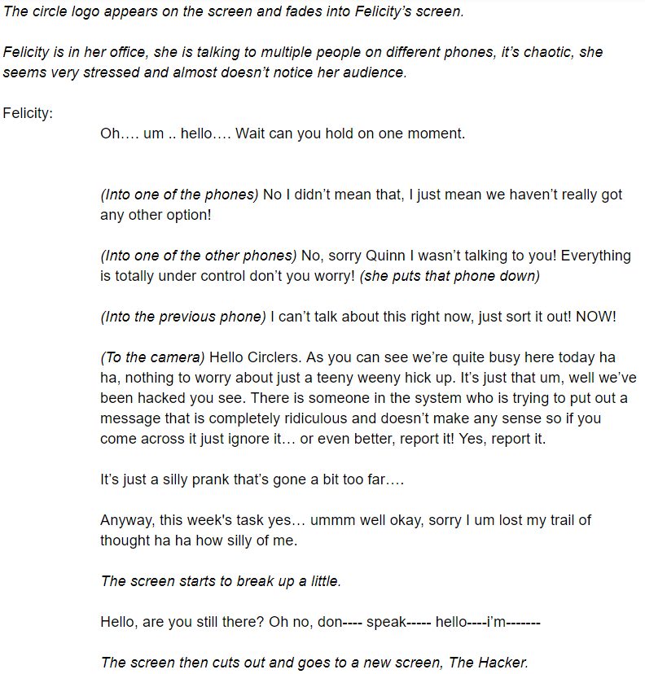
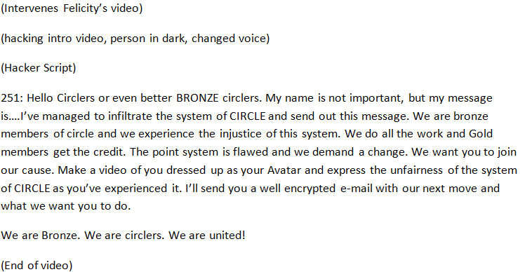
Link: “Link”
Reflection Question: What is considered fair or unfair? Could something fair for some be unfair for others?
- Into Action: Next Move
The participants are given the context of the assignment that the Hacker No 251 talked about, asking them to create a video.
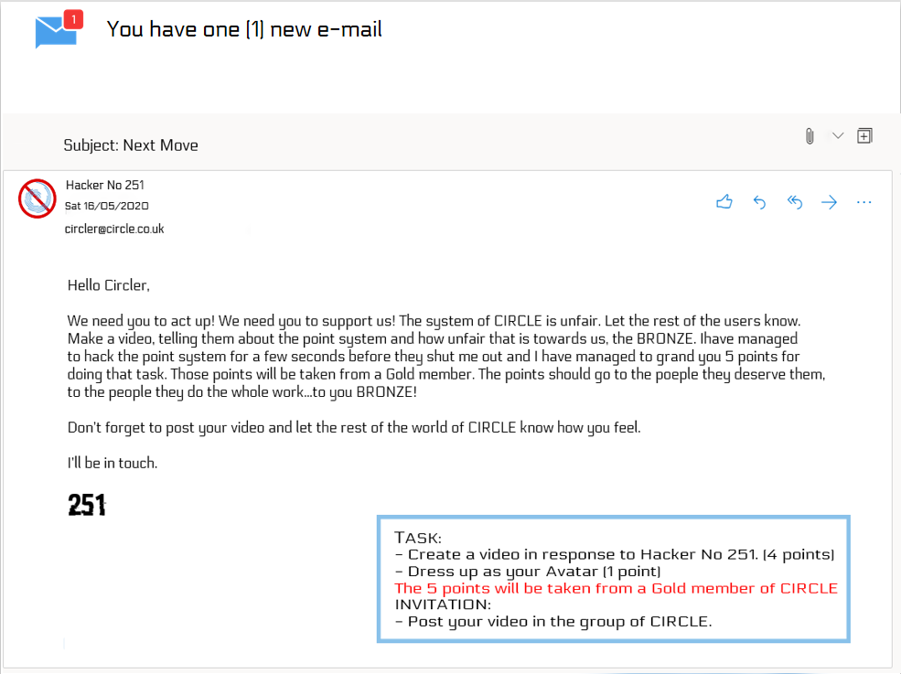
Reflection Questions: Is redistribution of wealth the solution to a capitalist system? Does the end justify the means?
- Building Belief: Message from Founder
The participants receive a follow up e-mail from the founder of CIRLCE, Quinn Wright, explaining to them that there is nothing to worry about and prompting them to find out who is that hacker No 251 and as a thank you, Quinn Wright will promote them to Gold member of CIRCLE.
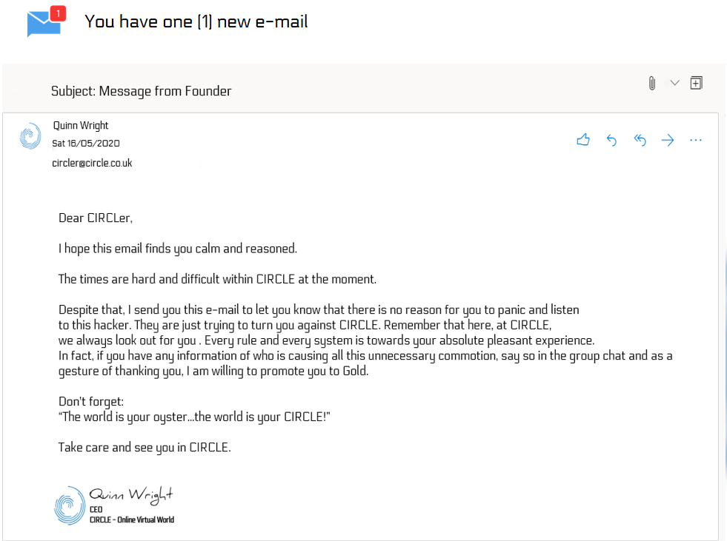

- Reflection: Consider this…
The group is offered a video message from one of the facilitators (out-of-role) asking them some of the reflection questions offered in the workshop plan along with critical questions on the topics and themes touched in this week’s workshop plan.
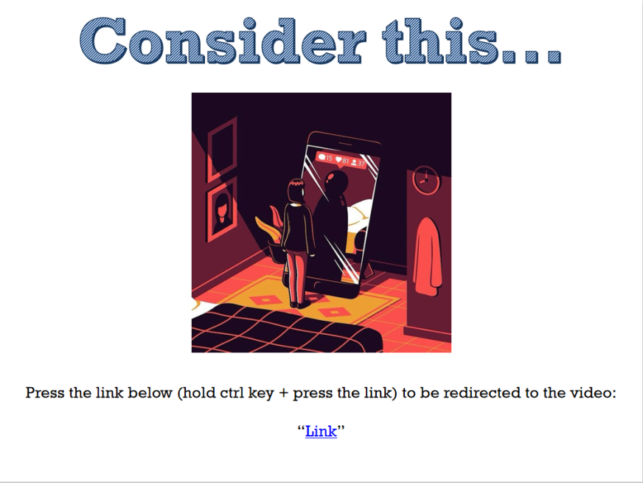
(Video Script)
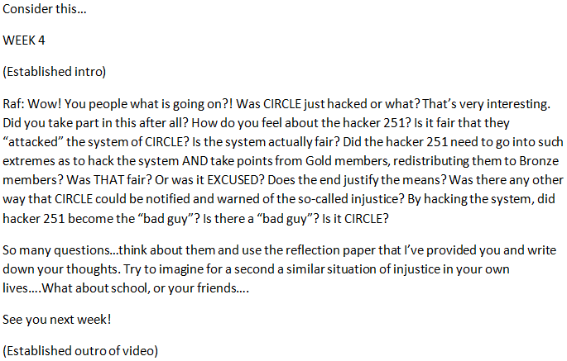
Link: “Link”
- Reflection Paper
The group is given a reflection paper template to help them reflect on the questions that have been asked by the facilitator out-of-role. They can either print out or copy that paper.
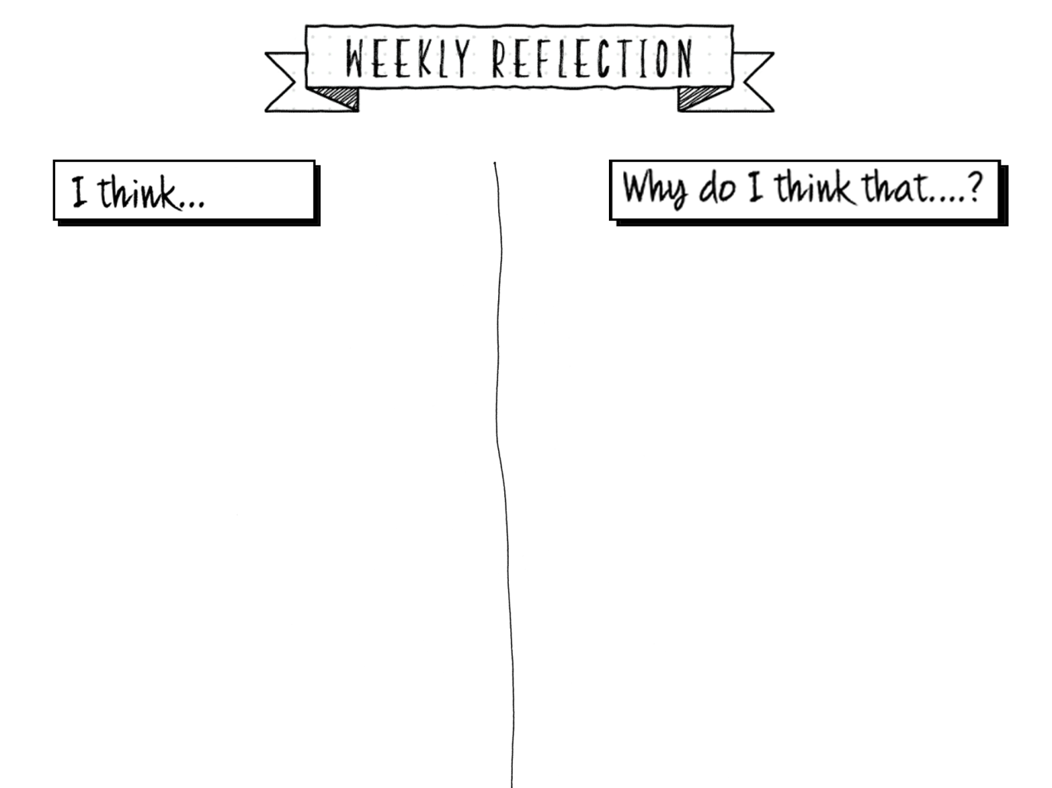
Workshop ends

