Process Drama
[CIRCLE]
Aby Watson

Rafael Tsantes
Nell O’Hara
5/11/2020

Learning questions: How is capitalism embedded in a trading system?

Themes that arise from the workshop are capitalism and trade relationships.

By the end of this workshop participants should have:
- Engaged with the idea of capitalism and trade relationships
Materials:
- Laptop/Desktop/Smartphone/Tablet accessibility
- Internet Connection
- Drawing materials e.g. markers, pens etc.
- A4 blank papers
- Pieces of clothing as props
- A recording device e.g. digital camera, smartphone etc.
Outline plan
- Video Message (in-character)
- Trading System Explanation/Laws
- TikTok Video
- Consider this…
- Reflection paper
Detailed Plan
Each task is given in an individual “.pdf” page, making it clearer and easier for the participant to be engaged.
- Lure: Video Message (in-character)
One of the facilitators assumes a character within the world of CIRCLE. They are the “Communications Officer” of CIRCLE and they introduce this week’s task.
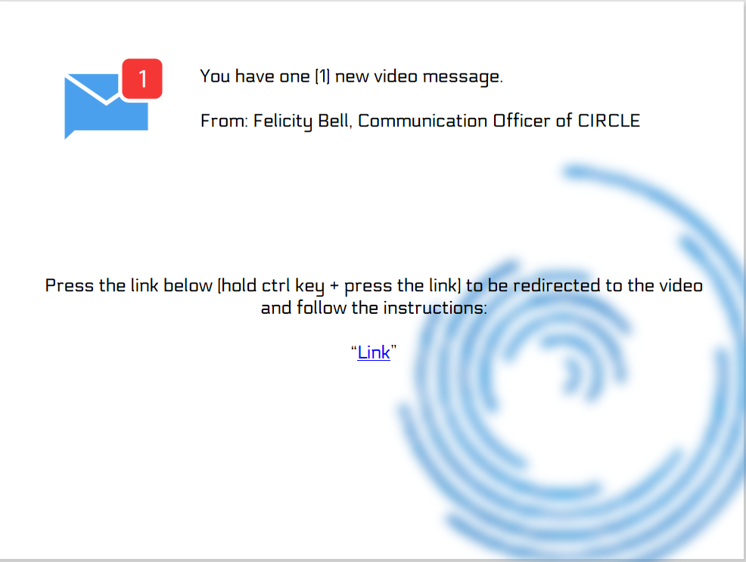

(video script)
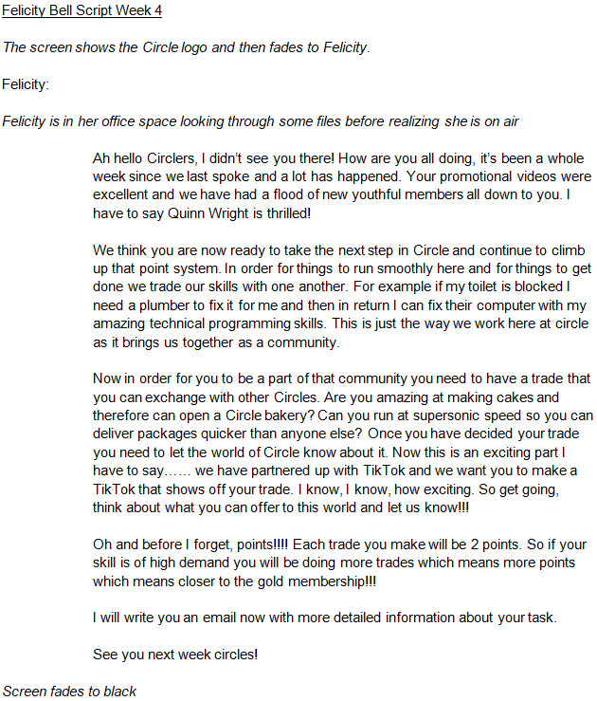
Link: “”
Reflection Question: How is an awarding system beneficial to each level of hierarchy? What does practically mean for someone to be on the top or the bottom?
- Building belief: Trading System Explanation/Laws
The participants are given the context of the new trading system along with the laws that constitute that system via an e-mail from Felicity Bell, Communications Officer of CIRCLE (facilitator in-role).
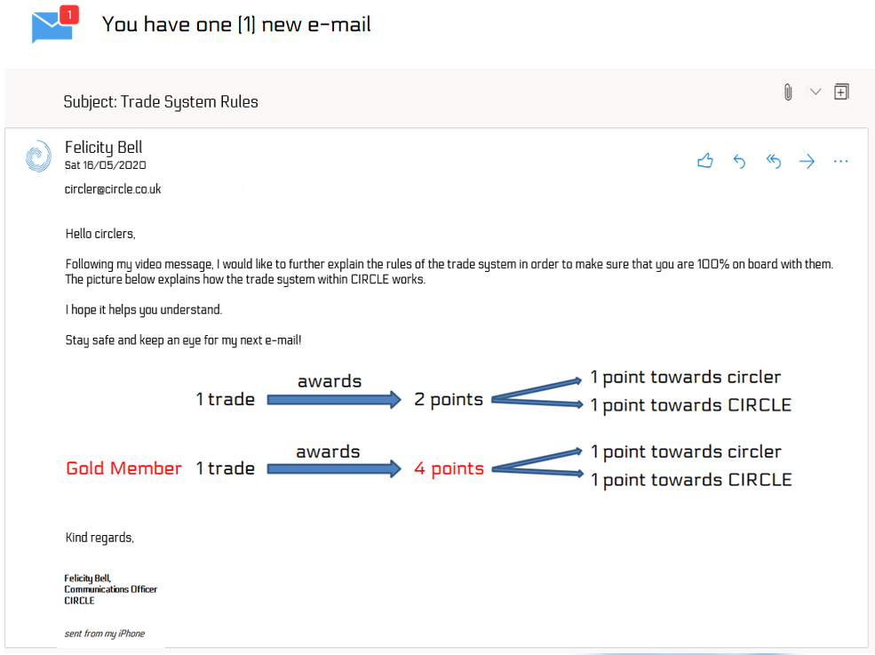
Reflection Question: What are the criteria that a systems needs to meet in order to be considered fair? How could an awarding system be in favour of the people on the upper levels?
- Into action: TikTok Video
The group is given a follow up e-mail from Felicity Bell, Communication Officer of CIRCLE (facilitator in-role) explaining that CIRCLE is collaborating with TikTok and they are asked to advertise their trade through a TikTok video. They are also invited to post their creations in the group chat.
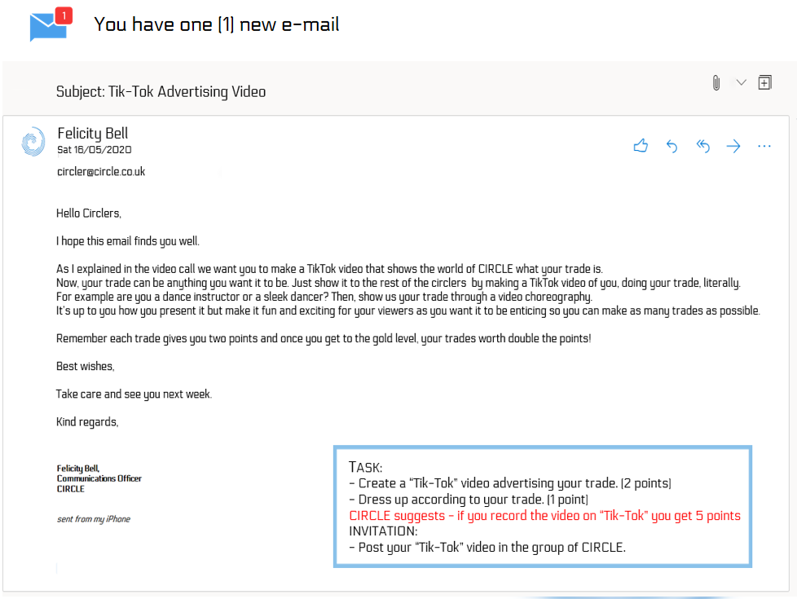

- Reflection: Consider this…
The group is offered a video message from one of the facilitators (out-of-role) asking them some of the reflection questions offered in the workshop plan along with critical questions on the topics and themes touched in this week’s workshop plan.
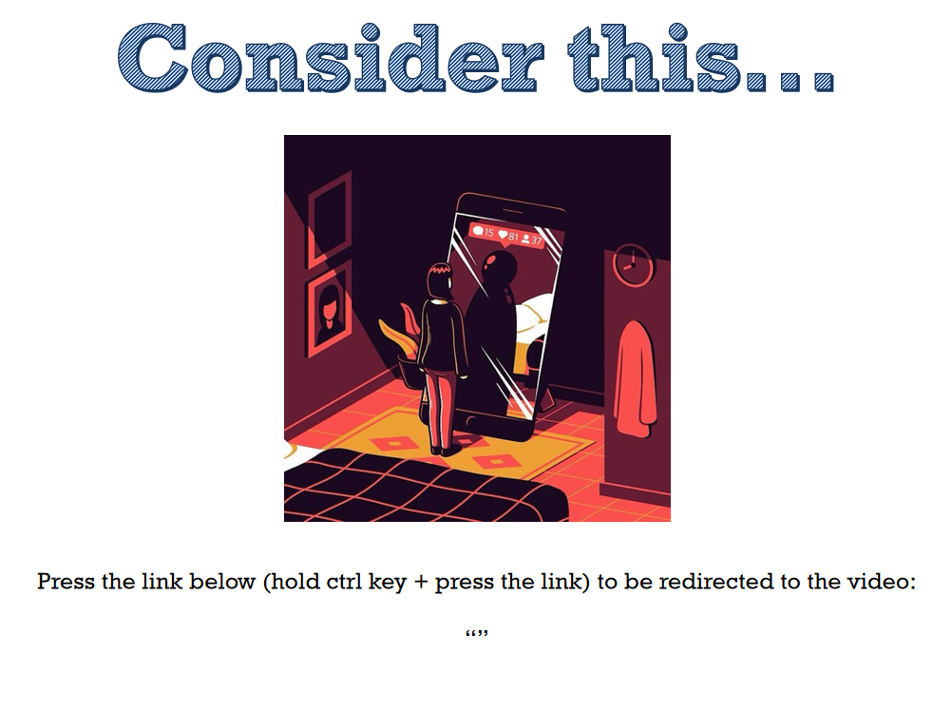
(Video Script)
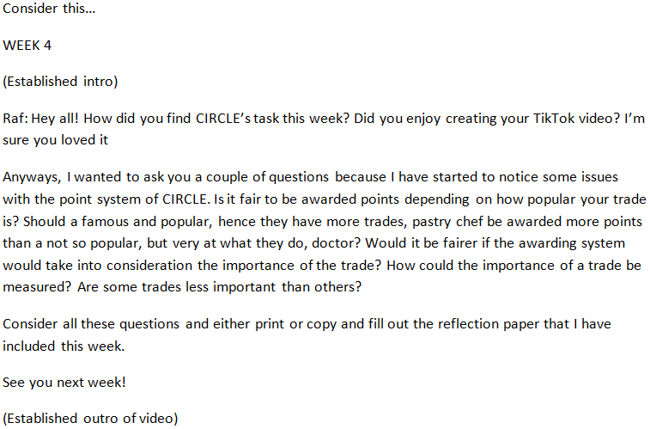
Link: “”
- Reflection Paper
The group is given a reflection paper template to help them reflect on the questions that have been asked by the facilitator out-of-role. They can either print out or copy that paper.
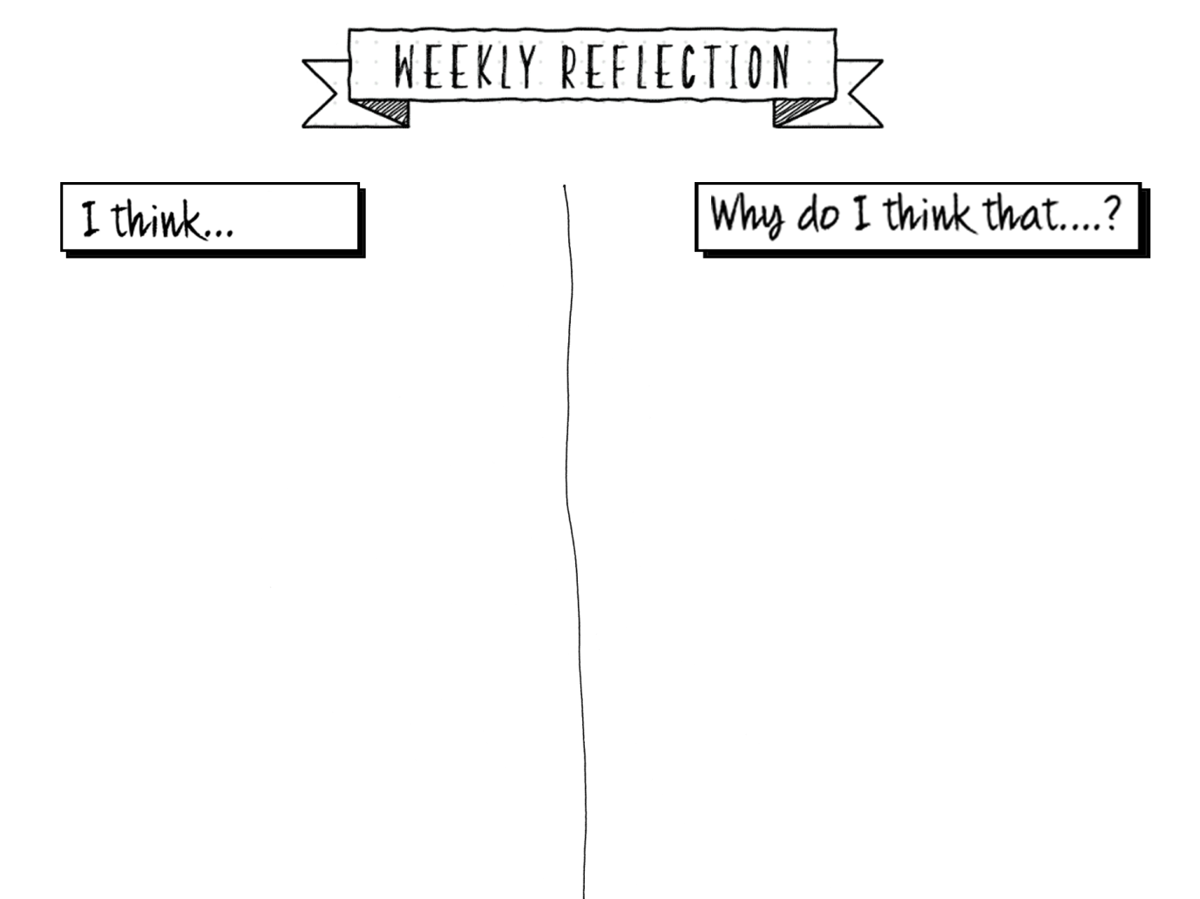
Workshop ends

